1.What is data cleaning, and why is it important in data analysis?
What are the potential consequences of analyzing unclean or messy data?
Explain the common steps involved in cleaning and organizing data?
Answer- Data cleaning is fixing errors, inconsistencies, and irrelevant info in datasets to ensure data quality, making analysis reliable; without it, you get inaccurate insights, poor decisions, wasted resources, and damaged reputation, with common steps including profiling, removing duplicates/irrelevant data, fixing errors (formats, missing values), and validating accuracy, creating a trustworthy foundation for analytics.
Consequences of unclean or messy Data
- Inaccurate Insights: Flawed algorithms and unreliable outcomes.
- Wasted Resources: Misdirected marketing, lost productivity, and reduced ROI.
- Poor Customer Experience: Ineffective campaigns and damaged brand reputation.
- Operational Issues: Slower sales cycles and misaligned teams.
Common Steps in Data Cleaning
- Assess & profile Data: Understand the data's structure, identify errors, missing values, and inconsistencies.
- Remove Irrelevant Data: Delete data not needed for the analysis.
- Handle Duplicates: Find and remove duplicate records.
- Fix Structural Errors: Correct formatting, spelling, and unit inconsistencies (e.g., "USA" vs. "U.S.A.").
- Address Missing Values: Decide whether to fill (impute) or remove incomplete data.
- Validate data: Verify data accuracy against rules or external sources.
- Iterate: Repeat the process as new data is added.
2. How would you sort the following dataset first by "Department" (A-Z) and then by "Salary" (Largest to Smallest)? Write a step-by-step approach.
Answer- First we select the department raw and then go to editing ribbon section in home tab where there is a function of sorting select sort A to Z then enter the data will be arranged in A to Z manner same for salary we go to editing section in home tab and select the sorting largest to smallest.
3. Explain the use of text functions such as TRIM , LEFT, RIGHT, MID, and CONCAT in data cleaning.
Answer- Trim function- Trim function is basically use to remove unnecessary space from the data and left with some spaces that needed on the data.
Left function- Extracts a specified number of characters from the beginning (left side) of a text string.
Right function- Extract a specified number of characters from the end (right side) of a text string.
Mid function- Extract a specific number of characters from the middle of a text string, starting at a user-defined position.
Concat function- Combines the text from multiple cells or strings into a single cell.
4. What is the role of date functions like TODAY in managing datasets?
Answer- Date functions like TODAY() play a crucial role in managing datasets by allowing for the incorporation of dynamic, time-sensitive information, which is vital for real-time analysis, automation, and reporting.
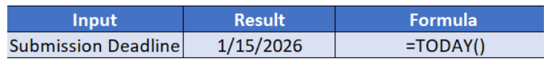
5.Apply Data Validation to restrict Quantity values to only whole numbers between 1 and 10.
- Configure an input message that appears when a user selects a cell in the "Quantity" column, explaining: "Please enter a whole number between 1 and 10."
- Set up an error alert message that triggers if the user enters a number less than 1 or greater than 10, showing:
"Invalid input! The quantity must be a whole number between 1 and 10."
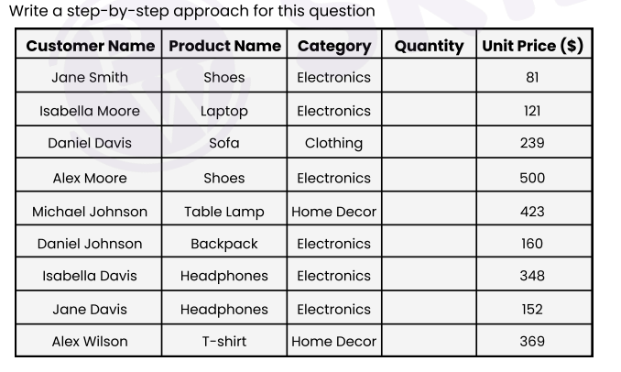
Answer- Step-by-Step Approach for Data Validation
Step 1: Select the Target Cells
Highlight the cells in the Quantity column where you want the rule to apply (e.g., from the first empty cell under "Quantity" down to the last row of data).
Step 2: Open Data Validation Settings
- Go to the Data tab on the top ribbon.
- Click on Data Validation (icon usually looks like a checkmark and a "cancel" sign).
- A dialogue box will open with three tabs: Settings, Input Message, and Error Alert.
Step 3: Configure the Validation Criteria (The Rule)
- In the Settings tab, look for the "Allow" dropdown menu.
- Change it from "Any value" to Whole number.
- Under "Data", ensure it is set to between.
- Set the Minimum value to 1.
- Set the Maximum value to 10.
Step 4: Configure the Input Message (Part 'a' of your question)
- Switch to the Input Message tab in the same dialogue box.
- Make sure "Show input message when cell is selected" is checked.
- In the Input message box, type exactly what the assignment asks:
  - "Please enter a whole number between 1 and 10."
Step 5: Configure the Error Alert (Part 'b' of your question)
- Switch to the Error Alert tab.
- Make sure "Show error alert after invalid data is entered" is checked.
- Set the Style to Stop (this prevents invalid data from being saved).
- In the Error message box, type the required text:
  - "Invalid input! The quantity must be a whole number between 1 and 10."
  - Click OK to finish.
6.Understand and apply fundamental text functions like LEFT, RIGHT, MID, and LEN?
- Extract the first 5 characters from the string "ExcelTipsAreGreat" using the LEFT function.
- Extract the last 4 characters from "DataAnalysis.xlsx" using the RIGHT function.
- Extract the substring "Tips" from "ExcelTipsAreGreat" using the MID function.
- Count the total number of characters in the string "Hello World!" using the LEN function.
- Create a formula to extract the middle 6 characters from "12345-67890-ABCDE".
Answer- 1.Extract the first 5 characters from the string "ExcelTipsAreGreat" using the LEFT function-
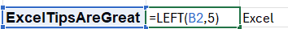
Explain-First we start left function with equal to and type LEFT than open bracket and select the cell where ExcelTipsAreGreat is written and than put , and type 5 for the first 5 characters from string and get answer “EXCEL”.
2. Extract the last 4 characters from "DataAnalysis.xlsx" using the RIGHT function.
Explain-First we start right function with equal to and type RIGHT than open bracket and select the cell where “DataAnalysis.xlsx" is written and than put , and type 4 for the first 4 characters from string and get answer “xlsx”.
3.Extract the substring "Tips" from "ExcelTipsAreGreat" using the MID function.

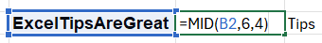
Explain-First we start MID function with equal to type MID than open bracket and select the cell where ExcelTipsAreGreat is written and than put , and type 6 because we need to extract tips which is starting from 6 and than type 4 because its 4 letter word which get answer “TIPS”.

4.Count the total number of characters in the string "Hello World!" using the LEN function.
Explain- we apply LEN function to get length of word in chosen cell.
5.Create a formula to extract the middle 6 characters from "12345-67890-ABCDE".

Explain- we apply function of MID to get 6 character as requested we type = to than MID function and than select cell and we skip 6 character and also put 6 because we need mid 6 character and answer “-67890”
7. Understand how to combine text using CONCAT, TEXTJOIN, and the & operator.
- Use CONCAT to combine "Hello" and "World" with a space in between.
- Combine "Apple", "Banana", and "Cherry" into a single string separated by commas using TEXTJOIN.
- Use the & operator to create the string "2025: Excel Functions" by combining "2025", ": ", and "Excel Functions".
- Create a comma-separated list from the range A1:A5 using TEXTJOIN.
- Combine first names in column A with last names in column B to create full names in column C.
Answer- Use CONCAT to combine "Hello" and "World" with a space in between. -
Combine "Apple", "Banana", and "Cherry" into a single string separated by commas using TEXTJOIN-

Use the & operator to create the string "2025: Excel Functions" by combining "2025", ": ", and "Excel Functions". -
Create a comma-separated list from the range A1:A5 using TEXTJOIN.-
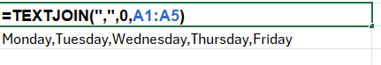

Combine first names in column A with last names in column B to create full names in column C.-
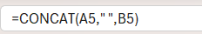
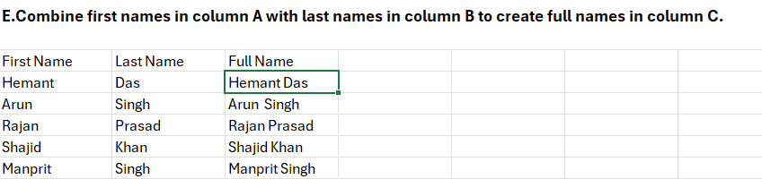

8. Understanding TODAY() and NOW()
a. What is the difference between TODAY() and NOW() in Excel? Provide an example of when you would use each function.
b. If cell A1 contains the date 2025-06-10, write a formula using TODAY() to determine how many days are left until that date.
c. Write an Excel formula using NOW() to display the current date and time in the format MM/DD/YYYY HH: MM AM/PM. ́
d. If a cell contains =TODAY(), what will happen when the worksheet is reopened the next day? Explain
e. You want to store a static date (today’s date) in a cell without it changing every day. What keyboard shortcut should you use?

Answer- A.TODAY(): Returns only the current date (e.g., 1/15/2026). It is best used for calculating durations based on days, such as age, years of service, or project deadlines.
- .NOW(): Returns the current date and the current time (e.g., 1/15/2026 14:30). It is best used for time-sensitive calculations, such as tracking exactly when a user logged in or calculating the precise hours elapsed since an event.
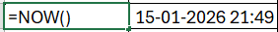
B.If cell A1 contains the date 2025-06-10, write a formula using TODAY() to determine how many days are left until that date.
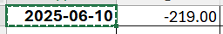
C. Write an Excel formula using NOW() to display the current date and time in the format MM/DD/YYYY HH: MM AM/PM. ́
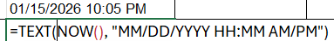
D.If a cell contains =TODAY(), what will happen when the worksheet is reopened the next day Explain-
When a worksheet containing the TODAY() function is reopened the next day, the function will recalculate and display the new, current date
- Volatile Function: TODAY() is a "volatile" function in spreadsheet programs like Microsoft Excel and Google Sheets [1, 2]. This means it does not store a fixed value; instead, it updates automatically every time the worksheet is opened or whenever any cell in the workbook is changed [1, 2].
- Automatic Update: When you open the file on a new day, the spreadsheet software recognizes the function and executes it again, pulling the current system date from your computer's clock.
- Result
: The cell will show the date of the day you reopened the worksheet, not the date from the previous day when you last saved it
E.You want to store a static date (today’s date) in a cell without it changing every day. What keyboard shortcut should you use
To insert a static (non-changing) date in a spreadsheet cell, use the keyboard shortcut Ctrl + ; (semicolon) on Windows.

